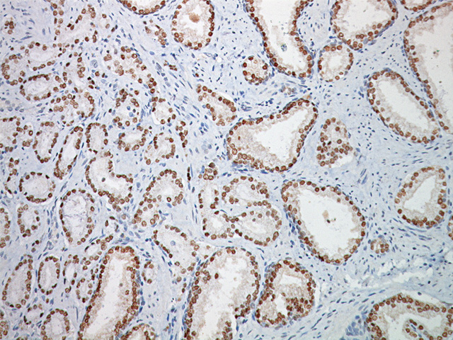

NKX3.1

SKU: 422.Categories: N, Primary Antibodies.

NKX3.1 is a protein encoded by the NKX3-1 gene and has been found to be positive in the vast majority of primary prostatic adenocarcinomas. A study has shown the sensitivity for identifying metastatic prostatic adenocarcinomas was 98.6% (68/69 cases positive) for NKX3.1 and 94.2% (65/69 cases positive) for prostate specific antigen (PSA). The specificity of NKX3.1 was 99.7% in various cancers and stains nuclei in both normal and prostate cancer. NKX3.1 antibody, used in combination with ERG monoclonal antibody [9FY], may represent a superior combination to aid in identifying tumors of prostatic origin.
INTENDED USE | IVD
SPECIES REACTIVITY | Human
SOURCE | Rabbit Polyclonal
CLONE | N/A
ISOTYPE | N/A
ANTIGEN | Human NKX3.1 protein
LOCALIZATION | Nuclear
POSITIVE CONTROL | Normal prostate or prostate cancer

